Attribute:

It can be seen as a data field that represents the characteristics or features of a data object. For a customer, object attributes can be customer Id, address, etc. We can say that a set of attributes used to describe a given object are known as attribute vector or feature vector.

For data-preprocessing, we have to differentiate between different types of attributes and then process the data.

attribute types.

Qualitative (Nominal (N), Ordinal (O), Binary(B)).

Quantitative (Numeric, Discrete, Continuous)

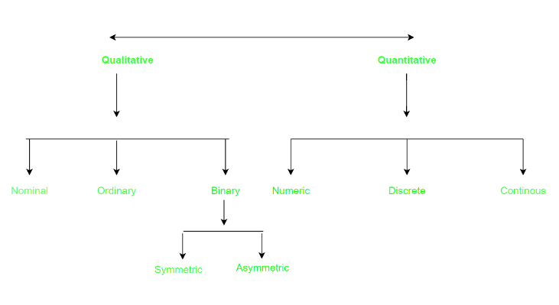

1. Qualitative attributes, also known as categorical or nominal attributes, are non-numeric in nature and are typically used to describe the categorical or nominal characteristics of data. Qualitative attributes are used to classify or categorize data into distinct groups or classes based on shared characteristics or properties.
2. Nominal Attributes – related to names: The values of a Nominal attribute are names of things, some kind of symbols. Values of Nominal attributes represent some category or state and that’s why nominal attribute also referred to as categorical attributes and there is no order (rank, position) among values of the nominal attribute.

Eg colors-black, brown, red

Profession - doctor, teacher, fireman

1. Binary Attributes: Binary data has only 2 values/states. For Example yes or no, affected or unaffected, true or false.

Symmetric: Both values are equally important (Gender).

Asymmetric: Both values are not equally important (Result)

1. Ordinal Attributes : The Ordinal Attributes contain values that have a meaningful sequence or ranking(order) between them, but the magnitude between values is not actually known, the order of values that shows what is important but don’t indicate how important it is.

II. Quantitative attributes, also known as numerical attributes, are variables that can be measured on a numeric scale. These attributes are used to describe measurable characteristics of data and can take on a wide range of numeric values.

1. Numeric: A numeric attribute is quantitative because it is a measurable quantity, represented in integer or real values. Numerical attributes are of 2 types, interval, and ratio.

**Interval scales** are measurement scales that have equal intervals between values, but do not have a true zero point. This means that while the intervals between values are equal, there is no absolute zero point at which the attribute being measured does not exist. Examples of interval scales include temperature scales such as Celsius or Fahrenheit. On an interval scale, the difference between 20 and 30 degrees is the same as the difference between 30 and 40 degrees, but 0 degrees does not represent the complete absence of temperature.

**Ratio scales**, on the other hand, are measurement scales that have both equal intervals between values and a true zero point. This means that not only are the intervals between values equal, but 0 represents the complete absence of the attribute being measured. Examples of ratio scales include weight, height, and time. On a ratio scale, the difference between 20 and 30 kilograms is the same as the difference between 30 and 40 kilograms, and 0 kilograms represents the complete absence of weight.

1. Discrete: Discrete attributes are used to describe data that can only take on a finite set of values. For example, the number of children in a family or the number of products sold are discrete attributes.
2. Continuous: Continuous attributes are used to describe data that can take on any value within a given range and can be measured at any level of precision. For example, weight, height are continuous attributes.

Statistical description of data:

Statistical description can be used to identify properties of the data and highlight which data values should be treated as noise or outliers.

These descriptive statistics are of great help in understanding the distribution of the data.

Descriptive statistics describe, show, and summarize the basic features of a dataset found in a given study, presented in a summary that describes the data sample and its measurements. It helps analysts to understand the data better.

Descriptive statistics represent the available data sample and do not include theories,

inferences, probabilities, or conclusions.

**Measures of Central Tendency**

Measures that indicate the approximate center of a distribution are called measures of central tendency.

A measure of central tendency is a single value that attempts to describe a set of data by identifying the central position within that set of data.

Measures of central tendency estimate a dataset's average or center, finding the result using three methods: mean, mode, and median.

**Mean:** The mean is also known as “M” and is the most common method for finding averages. You get the mean by adding all the response values together, and dividing the sum by the number of responses, or “N.” For instance, say someone is trying to figure out how many hours a day they sleep in a week. So, the data set would be the hour entries (e.g., 6,8,7,10,8,4,9), and the sum of those values is 52. There are seven responses, so N=7. You divide the value sum of 52 by N, or 7, to find M, which in this instance is 7.3.

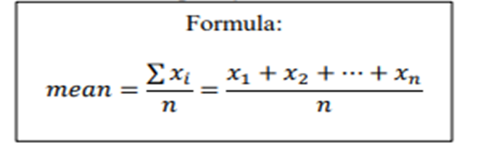

Although the mean is the single most useful quantity for describing a data set, it is not always the best way of measuring the center of the data.

A major problem with the mean is its sensitivity to extreme (outlier) values.

Even a small number of extreme values can corrupt the mean.

To offset the effect caused by a small number of extreme values, we can instead use the trimmed mean,

Trimmed mean can be obtained after chopping off values at the high and low extremes.

**Median:** The median, defined as the value in the precise center of the dataset. Arrange the values in ascending order (like we did for the mode) and look for the number in the set’s middle.

Suppose that a given data set of N distinct values is sorted in numerical order.

If N is odd, the median is the middle value of the ordered set;

If N is even, the median is the average of the middle two values.

In probability and statistics, the median generally applies to numeric data; however, we may extend the concept to ordinal data.

**Mode:** The mode is just the most frequent response value. Datasets may have any number of modes, including “zero.” You can find the mode by arranging your dataset's order from the lowest to highest value and then looking for the most common response. So, in using our sleep study from the last part: 4,6,7,8,8,9,10. As you can see, the mode is eight.

The mode for a set of data is the value that occurs most frequently in the set.

It is possible for the greatest frequency to correspond to several different values, which results in more than one mode.

Data sets with one, two, or three modes: called unimodal, bimodal, and trimodal.

At the other extreme, if each data value occurs only once, then there is no mode.

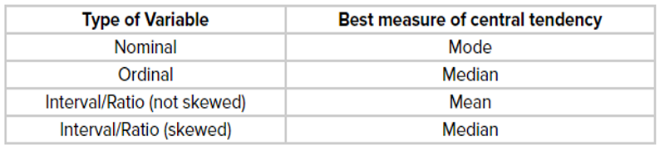

**Measure of Variability (Also Called Dispersion)**

The measure of variability gives the statistician an idea of how spread out the responses are. The spread has aspects — range, IQR, standard deviation, and variance.

Range: Use range to determine how far apart the most extreme values are. Start by subtracting the dataset’s lowest value from its highest value. Once again, we turn to our sleep study: 4,6,7,8,8,9,10. We subtract four (the lowest) from ten (the highest) and get six. There’s your range.

Standard Deviation: The standard deviation (s) is your dataset’s average amount of variability, showing you how far each score lies from the mean. The larger your standard deviation, the greater your dataset’s variable.

If the points are further from the mean, there is a higher deviation within the data but if they are closer to the mean, there is a lower deviation.

So the more spread out the group of numbers are, the higher the standard deviation.

Variance: Variance reflects the dataset’s degree spread. The greater the degree of data spread, the larger the variance relative to the mean. You can get the variance by just squaring the standard deviation.

The Interquartile Range (IQR)

The interquartile range is the middle half of the data. To visualize it, think about the median value that splits the dataset in half.

Similarly, you can divide the data into quarters. Statisticians refer to these quarters as quartiles and denote them from low to high as Q1, Q2, and Q3.

The lowest quartile (Q1) contains the quarter of the dataset with the smallest values.

The upper quartile (Q4) contains the quarter of the dataset with the highest values.

The interquartile range is the middle half of the data that is in between the upper and lower quartiles.

In other words, the interquartile range includes the 50% of data points that fall between Q1 and Q3. The IQR is the red area in the graph below.

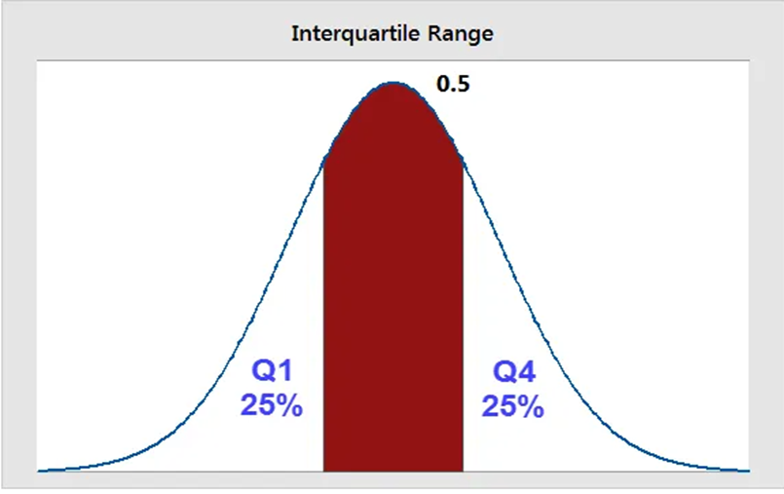

**Graphic Displays of statistical data**

Histograms: A graphical representation of the distribution of data that shows the frequency of values within specific intervals or bins.

Box plots: A graphical summary of the distribution of data that shows the median, quartiles, and outliers.

Scatter plots: A graph that shows the relationship between two variables, with each point representing a pair of values for the variables.

Line charts: A graph that shows how a variable changes over time or other continuous intervals.

Bar charts: A graph that uses bars to represent the frequency or proportion of categorical data.

Pie charts: A circular chart that shows the proportion of each category in a dataset.

Heat maps: A graphical representation of data where values are shown as colors on a grid, often used to show correlations between variables.

What is a box plot?

In descriptive statistics, a box plot or boxplot (also known as box and whisker plot) is a type of chart often used in exploratory data analysis.

Box plots visually show the distribution of numerical data and skewness through displaying the data quartiles (or percentiles) and averages.

Box plots show the five-number summary of a set of data: including the minimum score, first (lower) quartile, median, third (upper) quartile, and maximum score.

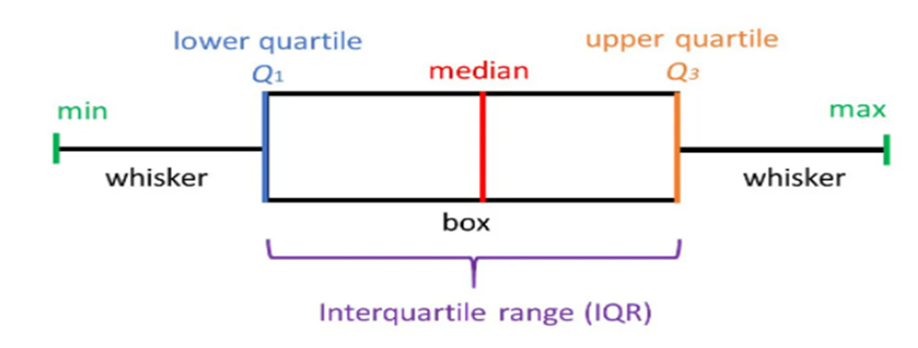

Minimum Score

The lowest score, excluding outliers (shown at the end of the left whisker).

Lower Quartile

Twenty-five percent of scores fall below the lower quartile value (also known as the first quartile).

Median

The median marks the mid-point of the data and is shown by the line that divides the box into two parts (sometimes known as the second quartile). Half the scores are greater than or equal to this value and half are less.

Upper Quartile

Seventy-five percent of the scores fall below the upper quartile value (also known as the third quartile). Thus, 25% of data are above this value.

Maximum Score

The highest score, excluding outliers (shown at the end of the right whisker).

Whiskers

The upper and lower whiskers represent scores outside the middle 50% (i.e. the lower 25% of scores and the upper 25% of scores).

The Interquartile Range (or IQR)

This is the box plot showing the middle 50% of scores (i.e., the range between the 25th and 75th percentile).

Box plots are useful as they show outliers within a data set.

An outlier is an observation that is numerically distant from the rest of the data.

When reviewing a box plot, an outlier is defined as a data point that is located outside the whiskers of the box plot. they show outliers within a data set.

Detecting Outliers

If a value is higher than the 1.5*IQR above the upper quartile (Q3), the value will be considered as outlier.

Similarly, if a value is lower than the 1.5*IQR below the lower quartile (Q1), the value will be considered as outlier.

IQR is an interquartile range. It measures dispersion or variation. IQR = Q3 -Q1.

Lower limit of acceptable range = Q1 - 1.5* (Q3-Q1)

Upper limit of acceptable range = Q3 + 1.5* (Q3-Q1)

Difference between bar graph and histogram?

A bar graph is used to compare discrete categories or groups, such as the frequency or proportion of different categories in a dataset. It consists of bars of equal width, where the height of each bar represents the value or frequency of each category. The bars in a bar graph are separated by gaps, and they can be arranged either horizontally or vertically.

On the other hand, a histogram is used to display the distribution of continuous data, such as the frequency or proportion of values within a range or bin. It consists of a series of contiguous rectangles (or bins), where the area of each rectangle represents the frequency or proportion of data within the range. The bins in a histogram are adjacent, and there are no gaps between them.

Why Data Preprocessing ?

Preprocessing data is an essential step in data analysis and machine learning. It involves a series of data cleaning, transformation, and normalization techniques to improve the quality and usability of the data for subsequent analysis. There are several reasons why preprocessing data is important:

Handling missing values: Real-world datasets often contain missing values, which can cause errors in analysis. Preprocessing techniques can be used to handle missing values by either removing them or imputing them with appropriate values.

Data transformation: Data transformation techniques, such as scaling, normalization, and feature extraction, can help to improve the quality and accuracy of the data by converting it into a more usable form for analysis.

Removing outliers: Outliers are data points that deviate significantly from the rest of the dataset, and they can affect the accuracy of statistical models. Preprocessing techniques can be used to identify and remove outliers from the data.

Handling categorical data: Many machine learning algorithms cannot handle categorical data directly, so preprocessing techniques, such as encoding and one-hot encoding, can be used to convert categorical data into numerical form.

Feature selection: Preprocessing techniques can be used to identify the most relevant features for a given problem, which can help to improve the accuracy of the model and reduce overfitting.

Improving model performance: Preprocessing data can help to improve the performance of machine learning models by reducing noise, increasing the signal-to-noise ratio, and improving the quality and relevance of the data.

Handling skewed data: Skewed data can cause problems in statistical analysis and machine learning. Preprocessing techniques, such as logarithmic transformation or power transformation, can be used to handle skewed data and improve the accuracy of the analysis.

Reducing dimensionality: Preprocessing techniques, such as principal component analysis (PCA) and singular value decomposition (SVD), can be used to reduce the dimensionality of the data and improve the efficiency and accuracy of machine learning models.

Addressing data imbalance: Imbalanced datasets, where one class is significantly more prevalent than others, can lead to biased machine learning models. Preprocessing techniques, such as oversampling or undersampling, can be used to address data imbalance and improve the accuracy of the model.

Enhancing interpretability: Preprocessing techniques can be used to enhance the interpretability of the data and improve the understanding of the relationships between variables, which can be useful in exploratory data analysis and hypothesis generation.

DATA SIMILARITY:

Data similarity refers to the degree of resemblance or closeness between two or more datasets, objects, or instances. It is an important concept in data analysis and machine learning, as it can help to identify patterns, detect outliers, and make predictions based on similarities between different datasets.

Measures of similarity:

1. Euclidean Distance: L2 norm

Euclidean distance is considered the traditional metric for problems with geometry. It can be simply explained as the ordinary distance between two points. It is one of the most used algorithms in cluster analysis. One of the algorithms that use this formula would be K-mean. Mathematically it computes the root of squared differences between the coordinates between two objects.

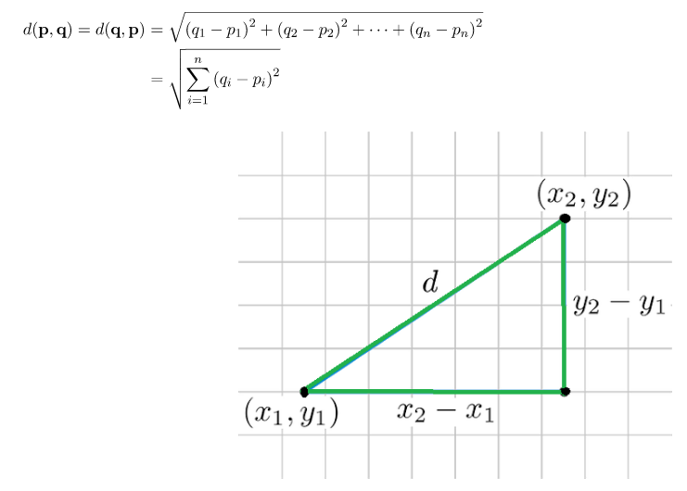

2. Manhattan Distance: L1 norm

This determines the absolute difference among the pair of the coordinates.

Suppose we have two points P and Q to determine the distance between these points we simply have to calculate the perpendicular distance of the points from X-Axis and Y-Axis.

In a plane with P at coordinate (x1, y1) and Q at (x2, y2).

Manhattan distance between P and Q = |x1 – x2| + |y1 – y2|

L- infinity norm = max(absolute differences between points)

3. Jaccard Similarity:

The Jaccard distance measures the similarity of the two data set items as the intersection of those items divided by the union of the data items.

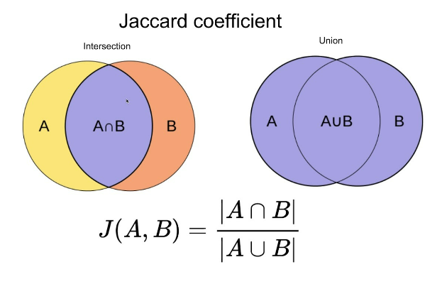

4. Minkowski distance:

It is the generalized form of the Euclidean and Manhattan Distance Measure. In an N-dimensional space, a point is represented as,

(x1, x2, ..., xN)

Consider two points P1 and P2:

P1: (X1, X2, ..., XN)

P2: (Y1, Y2, ..., YN)

Then, the Minkowski distance between P1 and P2 is given as:



When p = 2, Minkowski distance is same as the Euclidean distance.

When p = 1, Minkowski distance is same as the Manhattan distance.

5. Cosine Index:

Cosine similarity is a metric used to measure how similar the documents are irrespective of their size. Mathematically, it measures the cosine of the angle between two vectors projected in a multi-dimensional space. The cosine similarity is advantageous because even if the two similar documents are far apart by the Euclidean distance (due to the size of the document), chances are they may still be oriented closer together. The smaller the angle, higher the cosine similarity.

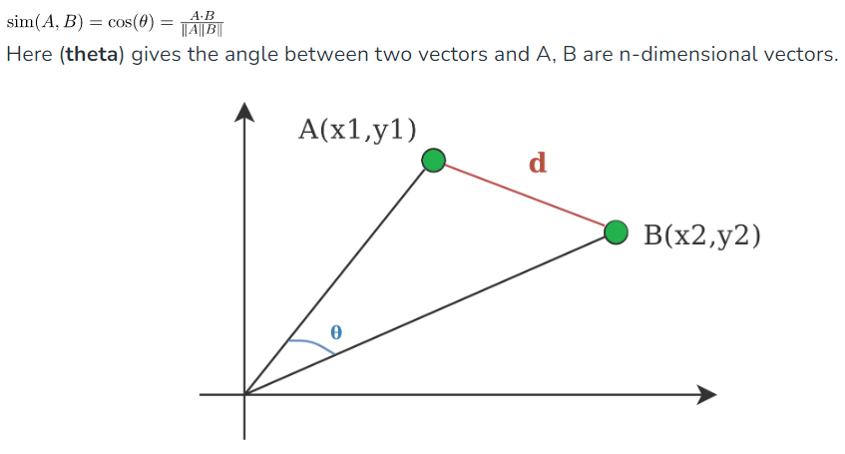

DATA DISSIMILARITY

Data dissimilarity is the opposite of data similarity and refers to the degree of difference or dissimilarity between two or more datasets, objects, or instances.

DATA REDUCTION:

Data reduction is a process that reduces the volume of original data and represents it in a much smaller volume. Data reduction techniques are used to obtain a reduced representation of the dataset that is much smaller in volume by maintaining the integrity of the original data. By reducing the data, the efficiency of the data mining process is improved, which produces the same analytical results.

Data reduction does not affect the result obtained from data mining. That means the result obtained from data mining before and after data reduction is the same or almost the same.

Data reduction aims to define it more compactly. When the data size is smaller, it is simpler to apply sophisticated and computationally high-priced algorithms. The reduction of the data may be in terms of the number of rows (records) or terms of the number of columns (dimensions).

<https://www.javatpoint.com/data-reduction-in-data-mining>

Attribute Subset Selection in Data Mining

Attribute subset Selection is a technique which is used for data reduction in data mining process. Data reduction reduces the size of data so that it can be used for analysis purposes more efficiently.

The goal of attribute subset selection is to find a minimum set of attributes such that dropping of those irrelevant attributes does not much affect the utility of data and the cost of data analysis could be reduced. Mining on a reduced data set also makes the discovered pattern easier to understand.

The brute force approach can be very expensive in which each subset (2^n possible subsets) of the data having n attributes can be analysed.

The best way to do the task is to use the statistical significance tests such that best (or worst) attributes can be recognized. Statistical significance test assumes that attributes are independent of one another.

All the above methods are greedy approaches for attribute subset selection.

Stepwise Forward Selection: This procedure start with an empty set of attributes as the minimal set. The most relevant attributes are chosen(having minimum p-value) and are added to the minimal set. In each iteration, one attribute is added to a reduced set.

Stepwise Backward Elimination: Here all the attributes are considered in the initial set of attributes. In each iteration, one attribute is eliminated from the set of attributes whose p-value is higher than significance level.

Combination of Forward Selection and Backward Elimination: The stepwise forward selection and backward elimination are combined so as to select the relevant attributes most efficiently. This is the most common technique which is generally used for attribute selection.

Decision Tree Induction: This approach uses decision tree for attribute selection. It constructs a flow chart like structure having nodes denoting a test on an attribute. Each branch corresponds to the outcome of test and leaf nodes is a class prediction. The attribute that is not the part of tree is considered irrelevant and hence discarded.

HISTOGRAM

A histogram is a graphical representation of a grouped frequency distribution with continuous classes. It is an area diagram and can be defined as a set of rectangles with bases along with the intervals between class boundaries and with areas proportional to frequencies in the corresponding classes. In such representations, all the rectangles are adjacent since the base covers the intervals between class boundaries. The heights of rectangles are proportional to corresponding frequencies of similar classes and for different classes, the heights will be proportional to corresponding frequency densities.

In other words, a histogram is a diagram involving rectangles whose area is proportional to the frequency of a variable and width is equal to the class interval.

You need to follow the below steps to construct a histogram.

Begin by marking the class intervals on the X-axis and frequencies on the Y-axis.

The scales for both the axes have to be the same.

Class intervals need to be exclusive.

Draw rectangles with bases as class intervals and corresponding frequencies as heights.

A rectangle is built on each class interval since the class limits are marked on the horizontal axis, and the frequencies are indicated on the vertical axis.

The height of each rectangle is proportional to the corresponding class frequency if the intervals are equal.

The area of every individual rectangle is proportional to the corresponding class frequency if the intervals are unequal.

The histogram graph is used under certain conditions. They are:

The data should be numerical.

A histogram is used to check the shape of the data distribution.

Used to check whether the process changes from one period to another.

Used to determine whether the output is different when it involves two or more processes.

Used to analyze whether the given process meets the customer requirements.

What is data sampling?

Data sampling is a statistical analysis technique used to select, manipulate and analyze a representative subset of data points to identify patterns and trends in the larger data set being examined.

In statistics, sampling is the process of selecting a subset of individuals or observations from a larger population in order to draw inferences or conclusions about the population as a whole. The subset of individuals selected for a study or analysis is called a sample, and the larger group from which the sample is drawn is called the population.

Sampling is a commonly used technique in research and data analysis, as it is often impractical or impossible to collect data from an entire population. Instead, a sample is selected that is representative of the population in terms of key characteristics or variables of interest.

There are several different types of sampling methods, including:

Simple random sampling: In this method, individuals are selected from the population at random, such that each individual has an equal chance of being selected.In this method, all the elements in populations are first divided into random sets of equal sizes. Random sets have no defining property among themselves, i.e one set cannot be identified from another set based on some specific identifiers. Thus every element has an equal property of being selected.

Stratified sampling: In this method, the population is divided into subgroups or strata based on some characteristic of interest, and individuals are then randomly selected from each subgroup in proportion to its size in the population.

Stratified Sampling is the most complex type of Sampling Method out of all the three methods mentioned above. It is a hybrid method concerning both simple random sampling as well as systematic sampling. It is one of the most advanced types of sampling method available, providing near accurate results to the tester. In this method, the population tray is divided into sub-segments also known as stratum(singular). Each stratum can have its own unique property. After being divided into different sub-stratum, SRS or Systematic Sampling can be used to create and pick out samples for performing statistics.

Cluster sampling: In this method, the population is divided into clusters or groups, and a random sample of clusters is selected. Then, all individuals within the selected clusters are included in the sample.

Systematic sampling: In this method, individuals are selected from the population at regular intervals, such as every 10th person.

Systematic Sampling is also known as a type of probability sampling. It is much more accurate than SRS and also the standard error formation percentage is very low but not error-free. In this method, first, the population tray elements are arranged based on a specific order or scheme properly known as being sorted. It can be of any order, which totally depends upon the person performing the statistics. The elements are first arranged either ascendingly, descending, lexicographically or any other known methods deemed fit by the tester. Although the start point needs to be random every time. After being arranged, then the sample elements are picked based on a pre-defined interval set or function. Example: In a random set of numbers with elements ranging from 1 to 100. The elements are first sorted either in ascending or descending order. Then let’s say every 4th element is picked to be a part of the sampling frame. This kind of sampling is known as Systematic Sampling.

Convenience sampling: In this method, individuals are selected based on their availability or willingness to participate, rather than on any predetermined sampling criteria.

data cube aggregation

In data warehousing and OLAP (Online Analytical Processing), data cube aggregation is a technique used to summarize and analyze data from multiple dimensions. A data cube is a multi-dimensional representation of data that allows for efficient querying and analysis of large data sets.

Data cube aggregation involves grouping data along one or more dimensions and calculating summary statistics for the resulting groups. For example, if we have a data cube with dimensions of time, product, and region, we could aggregate the data by time and region to calculate total sales for each time period in each region.

Aggregation can be performed on multiple dimensions simultaneously, allowing for complex analysis of data. For example, we could aggregate the data by product and region, and then further aggregate by time to analyze sales trends for specific products in different regions over time.

Aggregation functions commonly used in data cube aggregation include:

Sum: Calculates the total of a numeric measure for each group.

Count: Calculates the number of observations in each group.

Average: Calculates the mean of a numeric measure for each group.

Min/Max: Calculates the minimum or maximum value of a numeric measure for each group.

Median: Calculates the median value of a numeric measure for each group.

Suppose we have a sales data set with the following dimensions: time, product, and region. The time dimension has monthly data for the past year, the product dimension has data for each product sold, and the region dimension has data for each region in which the products were sold.

To analyze this data using data cube aggregation, we could aggregate the data by product and region to calculate total sales for each product in each region. We could then further aggregate the data by time to analyze sales trends over time.

Normalization

Normalization is a process of scaling and transforming data to ensure that it is consistent and accurate. In general, normalization involves transforming the data so that it falls within a specific range or follows a specific distribution. This can help reduce redundancy in the data and improve the accuracy and efficiency of data analysis.

There are several methods of normalization that can be used depending on the type of data being analyzed and the specific goals of the analysis. Some of the most common methods include:

Min-Max normalization: This method scales the data so that it falls within a specific range, typically between 0 and 1. The formula for min-max normalization is:

X' = (X - Xmin) / (Xmax - Xmin)

where X' is the normalized value, X is the original value, Xmin is the minimum value in the dataset, and Xmax is the maximum value in the dataset.

Min-max normalization is useful for ensuring that all values in the dataset are on a consistent scale. It can also be helpful when working with machine learning algorithms that require input data to fall within a specific range.

Z-score normalization: This method scales the data so that it has a mean of 0 and a standard deviation of 1. The formula for z-score normalization is:

X' = (X - mean) / standard deviation

where X' is the normalized value, X is the original value, mean is the mean value of the dataset, and standard deviation is the standard deviation of the dataset.

Z-score normalization is useful when working with datasets that have outliers or that follow a specific distribution, such as the normal distribution.

Decimal scaling normalization: This method scales the data by dividing each value by a power of 10, such that the resulting values fall within a specific range. For example, if the range of values in the dataset is between 100 and 1000, dividing each value by 1000 will result in values between 0.1 and 1. The formula for decimal scaling normalization is:

X' = X / 10^k

where X' is the normalized value, X is the original value, and k is a value that is chosen to ensure that all values fall within the desired range.

Normalization can be applied to both quantitative and qualitative data, but the specific method used may differ depending on the type of data and the analysis being performed. Normalization is typically performed as part of the data preprocessing and cleaning process, but it can also be used in data analysis and visualization to ensure that the data is on a consistent scale and is suitable for the analysis being performed.

BINNING

Binning, also known as discretization, is a data preprocessing technique used to transform a continuous numerical variable into a categorical feature. Binning involves dividing the range of a continuous variable into a set of discrete intervals or bins and then assigning each observation to the appropriate bin based on its value.

Binning can be useful in several ways, including:

Reducing the noise in the data: By grouping similar values into bins, binning can help reduce the effect of random variations in the data.

Handling outliers: Binning can help deal with outliers by assigning them to a specific bin based on their value.

Simplifying the analysis: Binning can simplify the data analysis process by reducing the number of unique values in a variable.

There are several techniques used for binning, including:

Equal-width binning: In this technique, the range of the data is divided into a fixed number of bins of equal width. For example, if we have data ranging from 0 to 100 and want to divide it into five bins, each bin would have a width of 20 (0-20, 20-40, 40-60, 60-80, and 80-100).

Equal-frequency binning: In this technique, the data is divided into a fixed number of bins, each containing approximately the same number of observations. For example, if we have 100 observations and want to divide the data into five bins using equal-frequency binning, each bin would contain approximately 20 observations.

Optimal binning: In this technique, the bins are created based on their relationship with the target variable. The goal is to create bins that maximize the difference between the target variable's values in each bin. This technique can be useful when the goal is to predict a specific outcome based on the binned data.

Binning is a useful data preprocessing technique that can help simplify the analysis process, reduce noise in the data, and handle outliers. However, it should be used carefully, as binning can also result in the loss of valuable information and can introduce bias in the analysis if not done properly.

HISTOGRAM ANALYSIS:

Histogram analysis is a graphical representation of the distribution of a set of continuous data into intervals known as bins or classes. The x-axis of the histogram represents the range of values of the variable being analyzed, and the y-axis represents the frequency or count of observations that fall into each bin.

Histogram analysis can help in identifying the shape of the distribution, the central tendency, the spread, the presence of outliers, and the potential presence of multiple modes. It can be used to analyze a variety of data types, including but not limited to financial data, customer data, scientific data, and environmental data.

Histogram analysis involves the following steps:

Determining the range of the data: The minimum and maximum values of the data set need to be determined to define the range of values.

Determining the number of bins: The number of bins should be chosen such that the data is not oversimplified or overcomplicated. Commonly used methods for selecting the number of bins include the square root, Sturges' formula, and the Freedman-Diaconis rule.

Creating the histogram: The data is then sorted into the appropriate bin and the height of each bin represents the frequency of data points in that bin.

Analyzing the histogram: The resulting histogram is then analyzed to understand the distribution of the data. This may involve identifying the central tendency, the spread of the data, the presence of outliers, and any potential multiple modes.

Histogram analysis can be done using various software tools such as Microsoft Excel, R, Python, MATLAB, and others. It is a useful tool in exploratory data analysis and can help in making data-driven decisions.

Example

Determining the range of the data: The minimum score is 50, and the maximum score is 100, so the range of the data is 50 to 100.

Determining the number of bins: We can use the square root rule to determine the number of bins. The square root of 30 is approximately 5.5, so we can choose 6 bins.

Creating the histogram: We can divide the range of the data (50 to 100) into 6 bins, each with a width of (100-50)/6 = 8.3. The bins would be 50-58.3, 58.3-66.6, 66.6-74.9, 74.9-83.2, 83.2-91.5, and 91.5-100. We would then count the number of scores that fall into each bin and plot them as the height of each bin on the y-axis.

Analyzing the histogram: The resulting histogram would show the distribution of the exam scores. We might see that most scores fall into the middle bins (66.6-83.2) with fewer scores in the lower and higher bins. This suggests a relatively normal distribution of scores. We might also notice that there are no scores in the 91.5-100 bin, indicating that no student scored above 91.5 on the exam. This could be a useful piece of information in identifying areas where students may need additional support or where the exam could be improved.